Chapter 8
Linear Programming: Sensitivity Analysis and Interpretation of Solution

Learning Objectives

1. Understand what happens in graphical solutions when coefficients of the objective function change.

2. Be able to interpret the range for an objective function coefficient.

3. Understand what happens in graphical solutions when right-hand sides change.

4. Be able to interpret the shadow price.

5. Be able to interpret the range for a right-hand side.

6. Understand the limitations of classical sensitivity analysis.

7. Learn how to formulate, solve and interpret the solution for linear programs with more than two decision variables.

8. Understand the following terms:

sensitivity analysis
shadow price
reduced cost
sunk cost
relevant cost

Solutions:

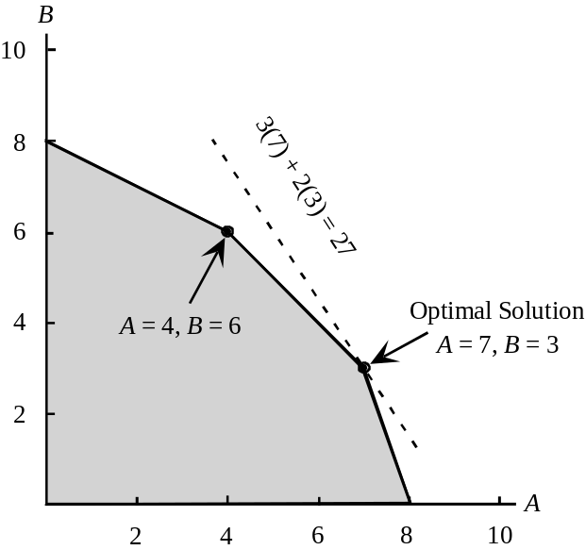1. a.

b. The same extreme point, A = 7 and B = 3, remains optimal.

The value of the objective function becomes 5(7) + 2(3) = 41

c. A new extreme point, A = 4 and B = 6, becomes optimal. The value of the objective function becomes 3(4) + 4(6) = 36.

d. The objective coefficient range for variable A is 2 to 6. Since the change in part (b) is within this range, we know the optimal solution, A = 7 and B = 3, will not change. The objective coefficient range for variable B is 1 to 3. Since the change in part (c) is outside this range, we have to re-solve the problem to find the new optimal solution.

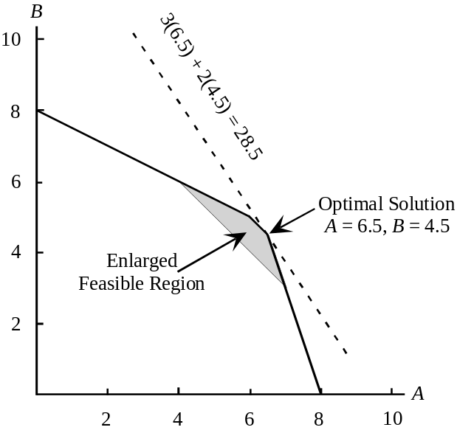2. a.
b. The value of the optimal solution to the revised problem is 3(6.5) + 2(4.5) = 28.5. The one-unit increase in the right-hand side of constraint 1 has improved the value of the optimal solution by 28.5 - 27 = 1.5. Thus, the shadow price for constraint 1 is 1.5.

c. The right-hand-side range for constraint 1 is 8 to 11.2. As long as the right-hand side stays within this range, the shadow price of 1.5 is applicable.

d. The improvement in the value of the optimal solution will be 0.5 for every unit increase in the right-hand side of constraint 2 as long as the right-hand side is between 18 and 30.

3. a.
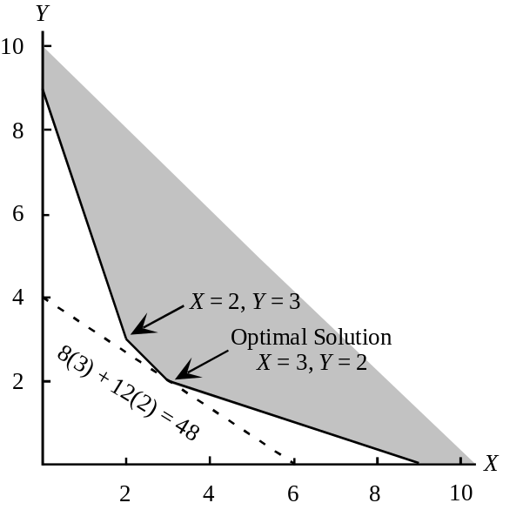

b. The same extreme point, X = 3 and Y = 2, remains optimal.

The value of the objective function becomes 6(3) + 12(2) = 42.

c. A new extreme point, X = 2 and Y = 3, becomes optimal. The value of the objective function becomes 8(2) + 6(3) = 34.

d. The objective coefficient range for variable X is 4 to 12. Since the change in part (b) is within this range, we know that the optimal solution, X = 3 and Y = 2, will not change. The objective coefficient range for variable Y is 8 to 24. Since the change in part (c) is outside this range, we have to re-solve the problem to find the new optimal solution.

4. a.
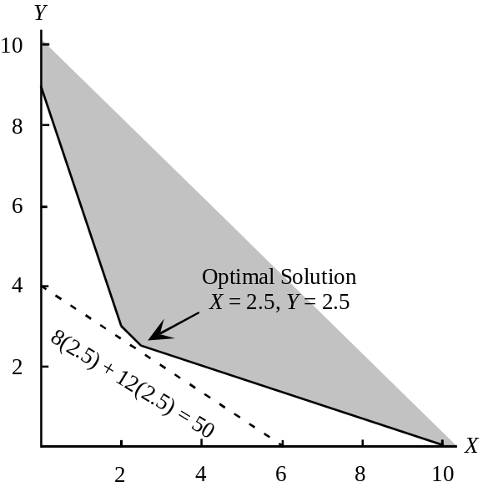

b. The value of the optimal solution to the revised problem is 8(2.5) + 12(2.5) = 50. Compared to the original problem, the value of the optimal solution has increased by 50 - 48 = 2. However, this is a minimization problem and the increase of 2 is not an improvement in the value of the optimal solution. In fact, the value of the optimal solution is worse by 2. Thus, the shadow price is 2.

c. The right-hand side range for constraint 1 is 5 to 11. As long as the right-hand side stays within this range, the shadow price of 2 is applicable. Since increasing the right-hand increases the value of the optimal solution, decreasing the right-hand side of constraint 1 would b desirable.

d. As long as the right-hand side of constraint 2 is between 9 and 18, a unit increase in the right-hand side will cause the value of the optimal solution to increase by 3.

5. a. Regular Glove = 500
Catcher’s Mitt = 150
Value = 5(500) + 8(150) = 3700

b. The finishing and packaging and shipping constraints are binding.

c. Cutting and Sewing = 0
Finishing = 3
Packaging and Shipping = 28

Additional finishing time is worth $3 per unit and additional packaging and shipping time is worth $28 per unit.

d. In the packaging and shipping department. Each additional hour is worth $28.

6. a. The optimal value for the Regular Glove variable is 5, the Allowable Decrease is 1 and the Allowable Increase is 7. The optimal value for the Catcher’s Mitt variable is 8, the Allowable Decrease is 4.667 and the Allowable Increase is 2. Therefore, we can express the Objective Coefficient Ranges as:

Variable | Objective Coefficient Range
Regular Glove | 5–1 = 4 to 5+7 = 12
Catcher’s Mitt | 8–4.667 = 3.333 to 8+2 = 10

b. As long as the profit contribution for the regular glove is between $4.00 and $12.00, the current solution is optimal.

As long as the profit contribution for the catcher's mitt stays between $3.33 and $10.00, the current solution is optimal.

The optimal solution is not sensitive to small changes in the profit contributions for the gloves.

c. The shadow prices for the resources are applicable over the following ranges:

Constraint | Right-Hand-Side Range
Cutting and Sewing | 900-175 = 725 to No Upper Limit
Finishing | 300-166.667 = 133.333 to 300+100 = 400
Packaging | 100-25 = 75 to 100+35 = 135

d. The shadow price of packaging and shipping constraint is 28, so the amount of increase = (28) (20) = $560

7. a. U = 800
H = 1200
Estimated Annual Return = 3(800) + 5(1200) = $8400

b. The Funds Available constraint and the Risk Maximum constraint are binding. All funds available are being utilized and the maximum permissible risk is being incurred.

c.
Constraint | Shadow Price
Funds Avail. | 0.093
Risk Max | 1.333
U.S. Oil Max | 0

d. No, the optimal solution does not call for investing the maximum amount in U.S. Oil.

8. a. The allowable increase for U.S. Oil is 7.000, so by more than $7.00 per share.

b. The allowable decrease for Huber Steel is 3.500, so by more than $3.50 per share.

- None. The allowable decrease for U.S. Oil maximum constraint is 200, and this is only a reduction of 100.

9. a. The optimal solution calls for the production of 560 jars of Western Foods Salsa and 240 jars of Mexico City Salsa; profit is 1(560) + 1.25(240) = $860.

b.
Variable | Objective Coefficient Range
Western Foods Salsa | 1.000-0.107 = 0.893 to 1.000 + 0.250 = 1.250
Mexico City Salsa | 1.250-0.250 = 1.000 to 1.250+0.150 = 1.400

c.

Constraint | Shadow Price | Interpretation
1 | 0.125 | One more ounce of whole tomatoes will increase profits by $0.125
2 | 0.000 | Additional ounces of tomato sauce will not improve profits; slack of 2080-1920 = 160 ounces.
3 | 0.188 | One more ounce of tomato paste will increase profits by $0.188

d.
Constraint | Right-Hand-Side Range
Whole tomatoes | 4480-160 = 4320 to 4480+1120 = 5600
Tomato sauce | 2080-160 = 1920 to No Upper Limit
Tomato paste | 1600-320 = 1280 to 1600+40 = 1640

10. a. S = 4000
M = 10,000
Total risk = 8(4000) + 3(10,000) = 62,000

b.
Variable | Objective Coefficient Range
S | 8.000-4.250=3.750 to No Upper Limit
M | No Upper Limit to 3.000+3.400 = 6.400

c. 5(4000) + 4(10,000) = $60,000

d. 60,000/1,200,000 = 0.05 or 5%

e. 0.057 risk units

f. 0.057(100) = 5.7%

11. a. No change in optimal solution; the allowable increase for the objective coefficient for S is infinite.

b. No change in the optimal solution; the allowable increase for the objective coefficient for M is 3.400.

c. No. Because more than one objective function coefficient is being changed here at the same time, we must resolve the problem to answer this question.
(Solving this problem with the new values for the objective function coefficients shows that the optimal solution does not change.)

12. a. E = 80, S = 120, D = 0

Profit = 63(80) + 95(120) + 135(0) = $16,440

b. The fan motors and cooling coils constraints are binding.

c. The manufacturing time constraint has slack; 2400-2080 = 320 hours are available.

d. This represents an increase in the objective function coefficient for D of $150-$135 = $15. Because this is less than the allowable increase of $24 for the objective function coefficient for D, there is no change in the optimal solution.

13. a. The range of optimality for each objective function coefficient is as follows:

E 63.000 – 15.5000 = 47.500 to 63.000+12.000 = 75
S 95.000-8.000 = 87.000 to 95.000+31.000 = 126
D No lower limit to135.000+24.000 = 159.000.

b. Because more than one objective function coefficient value is changing at the same time here, we must resolve the problem to answer this question. Resolving the problem with the new profit values shows that the optimal solution will not change.

However, the change in total profit will be 69(80) + 93(120) + 135(0) = $16,680

c. The range of feasibility for the right-hand side values for each constraint are as follows:

Fan motors constraint 200.000-40.000 = 160.000 to 200.000+80.000 = 280.000
Cooling coils constraint 320.000-120.000 = 200.000 to 320.000+80.000 = 400.000
Manufacturing time constraint 2400.000-320.000 = 2080.000 to No Upper Limit

d. Yes, 100 is greater than the allowable increase for the fan motors constraint (80.000).

The shadow price will change.

14. a. The optimal solution is to manufacture 100 cases of model A, 60 cases of model B and purchase 90 cases of model B

Total Cost = 10(100) + 6(60) + 14(0) + 9(90) = $2170

b. Demand for model A
Demand for model B
Assembly time

c.
Constraint | Shadow Price
1 | 12.25
2 | 9.0
3 | 0
4 | -0.375

If demand for model A increases by 1 unit, total cost will increase by $12.25
If demand for model B increases by 1 unit, total cost will increase by $9.00
If an additional minute of assembly time is available, total cost will decrease by $.375

d. The assembly time constraint. Each additional minute of assembly time will decrease costs by $.375. Note that this will be true up to a value of 1133.33 hours.
Some students may say that the demand constraint for model A should be selected because decreasing the demand by one unit will decrease cost by $12.25. But, carrying this argument to the extreme would argue for a demand of 0.

15. a.
Decision Variable | Ranges of Optimality
AM | No lower limit to 10.000+1.750 = 11.750
BM | 6.000-2.333 = 3.667 to 6.000+3.000 = 9.000
AP | 14.000-1.750 = 12.250 to No Upper Limit
BP | 9.000-3.000 = 6.000 to 9.000+2.333 = 11.333

Provided a single change of an objective function coefficient is within its above range, the optimal solution AM = 100, BM = 60, AP = 0, and BP = 90 will not change.

b. This change is within the range of optimality. (Equivalently, the increase in cost for Model A and decrease in cost for Model B are within the allowable increase (decrease for Model B).) The optimal solution remains AM = 100, BM = 60, AP = 0, and BP = 90. The $11.20 - $10.00 = $1.20 per unit cost increase will increase the total cost to $2170 + $1.20(100) = $2290.

c. Because more than one value is changing at the same time here, we must resolve the problem with the new manufacturing costs.
Resolving the problem provides the new optimal solution: AM = 0, BM = 135, AP = 100, and BP = 15; the total cost is $22,100.

16. a. The optimal solution calls for the production of 100 suits and 150 sport coats. Forty hours of cutting overtime should be scheduled, and no hours of sewing overtime should be scheduled. The total profit is 190(100) + 150(150) – 15(40) – 10(0) = $40,900.

b. This represents an increase of $20 for the suits produced coefficient. The allowable increase for this objective function coefficient is $35, so the optimal solution will not change. But, the value of the optimal solution will increase by ($210-$190)100 = $2000. Thus, the total profit becomes $42,990.

c. The slack for the material constraint is 0. Because this is a binding constraint, Tucker should consider ordering additional material. The shadow price of $34.50 is the maximum extra cost per yard that should be paid. Because the additional handling cost is only $8 per yard, Tucker should order additional material. Note that the shadow price of $34.50 is valid up to 133.33 additional yards (the allowable increase for the material constraint).

d. The shadow price of -$35 for the minimum suit requirement constraint tells us that lowering the minimum requirement by 25 suits will change profit by $-35(-25) = $875.

17. a. Produce 1000 units of model DRB and 800 units of model DRW

Total profit contribution = 200(1000) + 280(800) = $424,000

b. The shadow price for the steel available constraint is 8.800. Thus, each additional pound of steel will increase profit by $8.80. At $2 per pound Deegan should purchase the additional 500 pounds. Note: the allowable increase for the steel available constraint is approximately 909. Thus, the shadow price of $8.80 is applicable for an increase of as much as 909 pounds.

c. The assembly time constraint has a slack of 4000 hours. Increasing the number of hours of assembly time is not worthwhile.

d. The objective coefficient range for model DRB has an allowable decrease of $88. Thus, the optimal solution will not change; the value of the optimal solution will be $175(1000) + $280(800) = $399,000.

e. An increase of 500 hours or 60(500) = 30,000 minutes is less than the allowable increase (40,000 minutes) for the manufacturing time constraint. Thus, the shadow price of $0.60 per minute will not change.

18. a. The linear programming model is as follows:

Min | 30AN | + | 50AO | + | 25BN | + | 40BO
s.t.
 | AN | + | AO |  |  |  |  | ≥ | 50,000
 |  |  |  |  | BN | + | BO | ≥ | 70,000
 | AN |  |  | + | BN |  |  | ≤ | 80,000
 |  |  | AO |  |  | + | BO | ≤ | 60,000

b. Optimal solution:

 | New Line | Old Line
Model A | 50,000 | 0
Model B | 30,000 | 40,000

Total Cost $3,850,000

c. The first three constraints are binding because the Final Values for these constraints are equal to the R.H. Sides. The fourth constraint, with a slack of 20,000 is nonbinding.

d. The shadow price for the new production line capacity constraint is -15. Because the shadow price is negative, increasing the right-hand side of constraint 3 will cause the objective function to decrease. Thus, every one unit increase in the right hand side of this constraint will actually reduce the total production cost by $15. In other words, an increase in capacity for the new production line is desirable.

e. Because constraint 4 is not a binding constraint, any increase in the production line capacity of the old production line will have no effect on the optimal solution. Thus, there is no benefit in increasing the capacity of the old production line.

f. The reduced cost for Model A made on the old production line is 5. Thus, the cost would have to decrease by at least $5 before any units of model A would be produced on the old production line.

g. The right hand side range for constraint 2 shows an allowable decrease of 40,000. Thus, if the minimum production requirement is reduced 10,000 units to 60,000, the shadow price of 40 is applicable. Thus, total cost would decrease by 10,000(40) = $400,000.

19. a. Let P₁ = units of product 1
P₂ = units of product 2
P₃ = units of product 3

Max | 30P₁ | + | 50P₂ | + | 20P₃
s.t. | 0.5P₁ | + | 2P₂ | + | 0.75P₃ | ≤ | 40 | Machine 1
 | P₁ | + | P₂ | + | 0.5P₃ | ≤ | 40 | Machine 2
 | 2P₁ | + | 5P₂ | + | 2P₃ | ≤ | 100 | Labor
 | 0.5P₁ | - | 0.5P₂ | - | 0.5P₃ | ≤ | 0 | Max P₁
 | -0.2P₁ | - | 0.2P₂ | + | 0.8P₃ | ≥ | 0 | Min P₃
P₁, P₂, P₃ ≥ 0

The optimal solution is

Optimal Objective Value
1250.00000
Variable | Value | Reduced Cost
P1 | 25.00000 | 0.00000
P2 | 0.00000 | -7.50000
P3 | 25.00000 | 0.00000
Constraint | Slack | Shadow Price
1 | 8.75000 | 0.00000
2 | 2.50000 | 0.00000
3 | 0.00000 | 12.50000
4 | 0.00000 | 10.00000
5 | 15.00000 | 0.00000
Objective | Allowable | Allowable
Coefficient | Increase | Decrease
30.00000 | Infinite | 10.00000
50.00000 | 7.50000 | Infinite
20.00000 | 10.00000 | 4.28571
RHS | Allowable | Allowable
Value | Increase | Decrease
40.00000 | Infinite | 8.75000
40.00000 | Infinite | 2.50000
100.00000 | 6.66667 | 100.00000
0.00000 | 5.00000 | 25.00000
0.00000 | 15.00000 | Infinite

b. Machine Hours Schedule:
Machine 1 31.25 Hours
Machine 2 37.50 Hours

c. $12.50

d. Increase labor hours to 120; the new optimal product mix is

P₁ = 24
P₂ = 8
P₃ = 16
Profit = $1440

20. a. Let H = amount allocated to home loans
P = amount allocated to personal loans
A = amount allocated to automobile loans

Max | 0.07H | + | 0.12P | + | 0.09A
s.t.
 | H | + | P | + | A | = | 1,000,000 | Amount of New Funds
 | 0.6H | - | 0.4P | - | 0.4A | ≥ | 0 | Minimum Home Loans
 |  |  | P | - | 0.6A | ≤ | 0 | Personal Loan Requirement

b. H = $400,000 P = $225,000 A = $375,000
Total annual return = $88,750
Annual percentage return = 8.875%

c. The objective coefficient range for H is No Lower Limit to 0.101. Since 0.09 is within the range, the solution obtained in part (b) will not change.

d. The shadow price for constraint 1 is 0.089. The right-hand-side range for constraint 1 is 0 to No Upper Limit. Therefore, increasing the amount of new funds available by $10,000 will increase the total annual return by 0.089 (10,000) = $890.

e. The second constraint now becomes
-0.61H - 0.39P - 0.39A ≥ 0

The new optimal solution is
H = $390,000 P = $228,750 A = $381,250

Total annual return = $89,062.50, an increase of $312.50

Annual percentage return = 8.906%, an increase of approximately 0.031%.

21. a. Let S1 = SuperSaver rentals allocated to room type I
S2 = SuperSaver rentals allocated to room type II
D1 = Deluxe rentals allocated to room type I
D2 = Deluxe rentals allocated to room type II
B1 = Business rentals allocated to room type II

The linear programming formulation and solution is given.

MAX 30S1+20S2+35D1+30D2+40B2

S.T.

1) 1S1+1S2<130
2) 1D1+1D2<60
3) 1B2<50
4) 1S1+1D1<100
5) 1S2+1D2+1B2<120

The optimal solution is

Optimal Objective Value
7000.00000
Variable | Value | Reduced Cost
S1 | 100.00000 | 0.00000
D1 | 0.00000 | -5.00000
S2 | 10.00000 | 0.00000
D2 | 60.00000 | 0.00000
B2 | 50.00000 | 0.00000
Constraint | Slack | Shadow Price
1 | 20.00000 | 0.00000
2 | 0.00000 | 10.00000
3 | 0.00000 | 20.00000
4 | 0.00000 | 30.00000
5 | 0.00000 | 20.00000
Objective | Allowable | Allowable
Coefficient | Increase | Decrease
30.00000 | Infinite | 5.00000
35.00000 | 5.00000 | Infinite
20.00000 | 5.00000 | 20.00000
30.00000 | Infinite | 5.00000
40.00000 | Infinite | 20.00000
RHS | Allowable | Allowable
Value | Increase | Decrease
130.00000 | Infinite | 20.00000
60.00000 | 10.00000 | 20.00000
50.00000 | 10.00000 | 20.00000
100.00000 | 20.00000 | 100.00000
120.00000 | 20.00000 | 10.00000

20 SuperSaver rentals will have to be turned away if demands materialize as forecast.

b. RoundTree should accept 110 SuperSaver reservations, 60 Deluxe reservations and 50 Business reservations.

c. Yes, the effect of a person upgrading is an increase in demand for Deluxe accommodations from 60 to 61. From constraint 2, we see that such an increase in demand will increase profit by $10. The added cost of the breakfast is only $5.

d. Convert to a Type I room. From the shadow price for constraint 4 we see that this will increase profit by $30.

e. Yes. We would need the forecast of demand for each rental class on the next night. Using the demand forecasts, we would modify the right-hand sides of the first three constraints and resolve.

22. a. Let L = number of hours assigned to Lisa
D = number of hours assigned to David
S = amount allocated to Sarah

Max | 30L | + | 25D | + | 18S
s.t.
 | L | + | D | + | S | = | 100 | Total Time
 | 0.6L | - | 0.4D |  |  | ≥ | 0 | Lisa 40% requirement
 | -0.15L | - | 0.15D | + | 0.85S | ≥ | 0 | Minimum Sarah
 | -0.25L | - | 0.25D | + | S | ≤ | 0 | Maximum Sarah
 | L |  |  |  |  | ≤ | 50 | Maximum Lisa

b. L = 48 hours D = 72 Hours S = 30 Hours
Total Cost = $3780

c. The shadow price for constraint 5 is 0. Therefore, additional hours for Lisa will not change the solution.

d. The shadow price for constraint 3 is 0. Because there is No Lower Limit on the right-hand-side range, the optimal solution will not change. Resolving the problem without this constraint will also show that the solution obtained in (b) does not change. Constraint 3, therefore, is really a redundant constraint.

23. a. Let C₁ = units of component 1 manufactured
C₂ = units of component 2 manufactured
C₃ = units of component 3 manufactured

Max | 8C₁ | + | 6C₂ | + | 9C₃
s.t. | 6C₁ | + | 4C₂ | + | 4C₃ | ≤ | 7200
 | 4C₁ | + | 5C₂ | + | 2C₃ | ≤ | 6600
 |  |  |  |  | C₃ | ≤ | 200
 | C₁ |  |  |  |  | ≤ | 1000
 |  |  | C₂ |  |  | ≤ | 1000
 | C₁ |  |  |  |  | ≥ | 600
C₁, C₂, C₃ ≥ 0

The optimal solution is

C₁ = 600
C₂ = 700
C₃ = 200

b.
Variable | Objective Coefficient Range
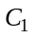 | No Lower Limit to 9.0
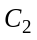 | 5.33 to 9.0
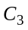 | 6.00 to No Lower Limit
Individual changes in the profit coefficients within these ranges will not cause a change in the optimal number of components to produce.

Constraint | Right-Hand-Side Range
1 | 4400 to 7440
2 | 6300 to No Upper Limit
3 | 100 to 900
4 | 600 to No Upper Limit
5 | 700 to No Upper Limit
6 | 514.29 to 1000

These are the ranges over which the shadow prices for the associated constraints are applicable.

d. Nothing, since there are 300 minutes of slack time on the grinder at the optimal solution.

e. No, since at that price it would not be profitable to produce any of component 3.

24. Let A = number of shares of stock A
B = number of shares of stock B
C = number of shares of stock C
D = number of shares of stock D

a. To get data on a per share basis multiply price by rate of return or risk measure value.

Min | 10A | + | 3.5B | + | 4C | + | 3.2D
s.t.
 | 100A | + | 50B | + | 80C | + | 40D | = | 200,000
 | 12A | + | 4B | + | 4.8C | + | 4D | ≥ | 18,000 | (9% of 200,00)
 | 100A |  |  |  |  |  |  | ≤ | 100,000
 |  |  | 50B |  |  |  |  | ≤ | 100,000
 |  |  |  |  | 80C |  |  | ≤ | 100,000
 |  |  |  |  |  |  | 40D | ≤ | 100,000
A, B, C, D ≥ 0

Solution: A = 333.3, B = 0, C = 833.3, D = 2500
Risk: 14,666.7
Return: 18,000 (9%) from constraint 2

b.
Max | 12A | + | 4B | + | 4.8C | + | 4D
s.t.
 | 100A | + | 50B | + | 80C | + | 40D | = | 200,000
 | 100A |  |  |  |  |  |  | ≤ | 100,000
 |  |  | 50B |  |  |  |  | ≤ | 100,000
 |  |  |  |  | 80C |  |  | ≤ | 100,000
 |  |  |  |  |  |  | 40D | ≤ | 100,000
A, B, C, D ≥ 0

Solution: A = 1000, B = 0, C = 0, D = 2500
Risk: 10A + 3.5B + 4C + 3.2D = 18,000
Return: 22,000 (11%)

c. The return in part (b) is $4,000 or 2% greater, but the risk index has increased by 3,333.

Obtaining a reasonable return with a lower risk is a preferred strategy in many financial firms. The more speculative, higher return investments are not always preferred because of their associated higher risk.

25. a. Let O1 = percentage of Oak cabinets assigned to cabinetmaker 1
O2 = percentage of Oak cabinets assigned to cabinetmaker 2
O3 = percentage of Oak cabinets assigned to cabinetmaker 3
C1 = percentage of Cherry cabinets assigned to cabinetmaker 1
C2 = percentage of Cherry cabinets assigned to cabinetmaker 2
C3 = percentage of Cherry cabinets assigned to cabinetmaker 3

Min | 1800 O1 | + | 1764 O2 | + | 1650 O3 | + | 2160 C1 | + | 2016 C2 | + | 1925 C3
s.t.
 | 50 O1 |  |  |  |  | + | 60 C1 |  |  |  |  | ≤ | 40 | Hours avail. 1
 |  |  | 42O2 |  |  |  |  | + | 48 C2 |  |  | ≤ | 30 | Hours avail. 2
 |  |  |  |  | 30 O3 |  |  |  |  | + | 35 C3 | ≤ | 35 | Hours avail. 3
 | O1 | + | O2 | + | O3 |  |  |  |  |  |  | = | 1 | Oak
 |  |  |  |  |  |  | C1 | + | C2 | + | C3 | = | 1 | Cherry
O1, O2, O3, C1, C2, C3 ≥ 0

Note: objective function coefficients are obtained by multiplying the hours required to complete all the oak or cherry cabinets times the corresponding cost per hour. For example, 1800 for O1 is the product of 50 and 36, 1764 for O2 is the product of 42 and 42 and so on.

b.
 | Cabinetmaker 1 | Cabinetmaker 2 | Cabinetmaker 3
Oak | O1 = 0.271 | O2 = 0.000 | O3 = 0.729
Cherry | C1 = 0.000 | C2 = 0.625 | C3 = 0.375

Total Cost = $3672.50

c. No, since cabinetmaker 1 has a slack of 26.458 hours. Alternatively, since the shadow price for constraint 1 is 0, increasing the right hand side of constraint 1 will not change the value of the optimal solution.

d. The shadow price for constraint 2 is -1.750. The upper limit on the right-hand-side range is 41.143. Therefore, each additional hour of time for cabinetmaker 2 will decrease total cost by $1.75 per hour, up to a maximum of 41.143 hours.

e. The new objective function coefficients for O2 and C2 are 42(38) = 1596 and 48(38) = 1824, respectively. The optimal solution does not change but the total cost decreases to $3552.50.

26. a. Let M₁ = units of component 1 manufactured
M₂ = units of component 2 manufactured
M₃ = units of component 3 manufactured
P₁ = units of component 1 purchased
P₂ = units of component 2 purchased
P₃ = units of component 3 purchased

Min | 4.50 M₁ |  | 5.00M₂ |  | 2.75M₃ |  | 6.50P₁ |  | 8.80P₂ |  | 7.00P₃
s.t. | 2M₁ |  | 3M₂ |  | 4M₃ |  |  |  |  |  |  | ≤ | 21,600 | Production
 | 1M₁ |  | 1.5M₂ |  | 3M₃ |  |  |  |  |  |  | ≤ | 15,000 | Assembly
 | 1.5M₁ |  | 2M₂ |  | 5M₃ |  |  |  |  |  |  | ≤ | 18,000 | Testing/Packaging
 | M₁ |  |  |  |  |  | 1P₁ |  |  |  |  | = | 6,000 | Component 1
 |  |  | 1M₂ |  |  |  |  |  | 1P₂ |  |  | = | 4,000 | Component 2
 |  |  |  |  | 1M₃ |  |  |  |  |  | 1P₃ | = | 3,500 | Component 3
M₁, M₂, M₃, P₁, P₂, P₃ ≥ 0

b.
Source | Component 1 | Component 2 | Component 3
Manufacture | 2000 | 4000 | 1400
Purchase | 4000 | 0 | 2100

Total Cost: $73,550

c. Since the slack is 0 in the production and the testing & packaging departments, these departments are limiting Benson's manufacturing quantities.

Shadow prices information:
Production $-0.906/minute x 60 minutes = $-54.36 per hour
Testing/Packaging $-0.125/minute x 60 minutes = $ -7.50 per hour

d. The shadow price is $7.969. This tells us that the value of the optimal solution will increase by $7.969 for an additional unit of component 2. Note that although component 2 has a purchase cost per unit of $8.80, it would only cost Benson $7.969 to obtain an additional unit of component 2.

27. a. LP Formulation
The objective function maximizes the total revenue generated from wet-harvested cranberries and dry-harvested cranberries. Each barrel of wet-harvested cranberries generates $17.50 in revenue; dry-harvested cranberries earn $32.50 per barrel. The first constraint ensures that no more than 5,000 total barrels of cranberries are harvested. The second constraint states that every barrel of wet-harvested cranberries requires 0.04 hours in the dechaffing operation, every barrel of dry-harvested cranberries requires 0.18 hours in the dechaffing operation, and there are 1008 dechaffing hours available . The third and fourth constraints represent similar requirements for the cleaning and drying operations.
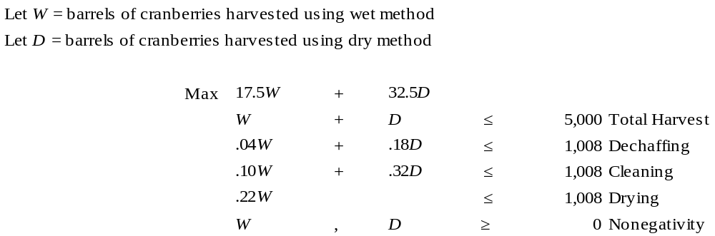

- The optimal solution is to harvest 2690.909 barrels of wet cranberries and 2309.091 barrels of dry cranberries.

- Below is the sensitivity analysis output for this problem:

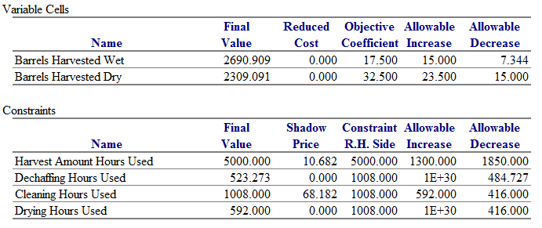
From this output, we see that dechaffing is not a binding constraint because only 523.273 of the 1008 available hours are being used. Fresh Made should not purchase additional dechaffing capacity.

- Assuming everything else remains unchanged, each additional hour of cleaning capacity added (subtracted) from the 1,008 available hours increases (decreases) revenues $68.18. This is true for any cleaning capacity value between 1008 – 416 = 592 and 1008 + 592 = 1600.
28. a. Let G = amount invested in growth stock fund
S = amount invested in income stock fund
M = amount invested in money market fund

Max | 0.20G | + | 0.10S | + | 0.06M
s.t.
 | 0.10G | + | 0.05S | + | 0.01M | ≤ | (0.05)(300,000) | Hartmann's max risk
 | G |  |  |  |  | ≥ | (0.10)(300,000) | Growth fund min.
 |  |  | S |  |  | ≥ | (0.10)(300,000) | Income fund min.
 |  |  |  |  | M | ≥ | (0.20)(300,000) | Money market min,
 | G | + | S | + | M | ≤ | 300,000 | Funds available
G, S, M ≥ 0

b. The solution to Hartmann's portfolio mix problem is given.

Optimal Objective Value
36000.00000
Variable | Value | Reduced Cost
G | 120000.00000 | 0.00000
S | 30000.00000 | 0.00000
M | 150000.00000 | 0.00000
Constraint | Slack | Shadow Price
1 | 0.00000 | 1.55556
2 | 90000.00000 | 0.00000
3 | 0.00000 | -0.02222
4 | 90000.00000 | 0.00000
5 | 0.00000 | 0.12000
Objective | Allowable | Allowable
Coefficient | Increase | Decrease
0.20000 | Infinite | 0.05000
0.10000 | 0.02222 | 1.20000
0.06000 | 0.14000 | 0.04000
RHS | Allowable | Allowable
Value | Increase | Decrease
0.00000 | 8100.00000 | 8100.00000
0.00000 | 90000.00000 | Infinite
0.00000 | 162000.00000 | 30000.00000
0.00000 | 90000.00000 | Infinite
300000.00000 | Infinite | 300000.00000
c. These are given by the objective coefficient ranges. The portfolio above will be optimal as long as the yields remain in the following intervals:

Growth stock 0.15 ≤ c₁ ≤ 0.60
Income stock No Lower Limit < c₂ ≤ 0.122
Money Market 0.02 ≤ c₃ ≤ 0.20

d. The shadow price for the first constraint provides this information. A change in the risk index from 0.05 to 0.06 would increase the constraint RHS by 3000 (from 15,000 to 18,000). This is within the right-hand-side range, so the shadow price of 1.556 is applicable. The value of the optimal solution would increase by (3000)(1.556) = 4668.

Hartmann's yield with a risk index of 0.05 is
36,000 / 300,000 = 0.12
His yield with a risk index of 0.06 would be
40,668 / 300,000 = 0.1356

e. This change is outside the objective coefficient range so we must re-solve the problem. The solution is shown below.

LINEAR PROGRAMMING PROBLEM

MAX .1G + .1S + .06M

S.T.

1) .1G + .05S + .01M < 15000
2) G > 30000
3) S > 30000
4) M > 60000
5) G + S + M < 300000

OPTIMAL SOLUTION

Optimal Objective Value
27600.00000
Variable | Value | Reduced Cost
G | 30000.00000 | 0.00000
S | 210000.00000 | 0.00000
M | 60000.00000 | 0.00000
Constraint | Slack | Shadow Price
1 | 900.00000 | 0.00000
2 | 0.00000 | 0.00000
3 | 180000.00000 | 0.00000
4 | 0.00000 | -0.04000
5 | 0.00000 | 0.09200
Objective | Allowable | Allowable
Coefficient | Increase | Decrease
0.10000 | 0.00000 | 0.92000
0.10000 | Infinite | 0.00000
0.06000 | 0.04000 | 0.33498
RHS | Allowable | Allowable
Value | Increase | Decrease
0.00000 | Infinite | 900.00000
0.00000 | 18000.00000 | 30000.00000
0.00000 | 180000.00000 | Infinite
0.00000 | 180000.00000 | 22500.00000
300000.00000 | Infinite | 299999.99999

f. The client's risk index and the amount of funds available.

g. With the new yield estimates, Pfeiffer would solve a new linear program to find the optimal portfolio mix for each client. Then by summing across all 50 clients he would determine the total amount that should be placed in a growth fund, an income fund, and a money market fund. Pfeiffer then would make the necessary switches to have the correct total amount in each account. There would be no actual switching of funds for individual clients.

29. a. Relevant cost since LaJolla Beverage Products can purchase wine and fruit juice on an as - needed basis.

b. Let W = gallons of white wine
R = gallons of rose wine
F = gallons of fruit juice

Max | 1.5 W | + | 1R | + | 2F
s.t.
 | 0.5W | - | 0.5R | - | 0.5F | ≥ | 0 | % white
 | -0.2W | + | 0.8R | - | 0.2F | ≥ | 0 | % rose minimum
 | -0.3W | + | 0.7R | - | 0.3F | ≤ | 0 | % rose maximum
 | -0.2W | - | 0.2R | + | 0.8F | = | 0 | % fruit juice
 | W |  |  |  |  | ≤ | 10000 | Available white
 |  |  | R |  |  | ≤ | 8000 | Available rose
W, R, F ≥ 0

Optimal Solution: W = 10,000, R = 6000, F = 4000
profit contribution = $29,000.

c. Since the cost of the wine is a relevant cost, the shadow price of $2.90 is the maximum premium (over the normal price of $1.00) that LaJolla Beverage Products should be willing to pay to obtain one additional gallon of white wine. In other words, at a price of $3.90 = $2.90 + $1.00, the additional cost is exactly equal to the additional revenue.

d. No; only 6000 gallons of the rose are currently being used.

e. Requiring 50% plus one gallon of white wine would reduce profit by $2.40.
Note to instructor: Although this explanation is technically correct, it does not provide an explanation that is especially useful in the context of the problem. Alternatively, we find it useful to explore the question of what would happen if the white wine requirement were changed to at least 51%. Note that in this case, the first constraint would change to 0.49W - 0.51R - 0.51F ≥ 0. This shows the student that the coefficients on the left-hand side are changing; note that this is beyond the scope of sensitivity analysis discussed in this chapter. Resolving the problem with this revised constraint will show the effect on profit of a 1% change.

f. Allowing the amount of fruit juice to exceed 20% by one gallon will increase profit by $1.00.

30. a. Let L = minutes devoted to local news
N = minutes devoted to national news
W = minutes devoted to weather
S = minutes devoted to sports

Min | 300L | + | 200N | + | 100W | + | 100S
s.t.
 | L | + | N | + | W | + | S | = | 20 | Time available
 | L |  |  |  |  |  |  | ≥ | 3 | 15% local
 | L | + | N |  |  |  |  | ≥ | 10 | 50% requirement
 |  |  |  |  | W | - | S | ≤ | 0 | Weather - sports
 | -L | - | N |  |  | + | S | ≤ | 0 | Sports requirement
 |  |  |  |  | W |  |  | ≥ | 4 | 20% weather
L, N, W, S ≥ 0

Optimal Solution: L = 3, N = 7, W = 5, S = 5
Total cost = $3,300

b. Each additional minute of broadcast time increases cost by $100; conversely, each minute reduced will decrease cost by $100. These interpretations are valid for increase up to 10 minutes and decreases up to 2 minutes from the current level of 20 minutes.

c. If local coverage is increased by 1 minute, total cost will increase by $100.

d. If the time devoted to local and national news is increased by 1 minute, total cost will increase by $100.

e. Increasing the sports by one minute will have no effect for this constraint since the shadow price is 0.

31. a. Let B = number of copies done by Benson Printing
J = number of copies done by Johnson Printing
L = number of copies done by Lakeside Litho

Min | 2.45B | + | 2.5J | + | 2.75L
s.t.
 | B |  |  |  |  | ≤ | 30,000 | Benson
 |  |  | J |  |  | ≤ | 50,000 | Johnson
 |  |  |  |  | L | ≤ | 50,000 | Lakeside
 | 0.9B | + | 0.99J | + | 0.995L | = | 75,000 | # useful reports
 | B | - | 0.1J |  |  | ≥ | 0 | Benson - Johnson %
 |  |  |  |  | L | ≥ | 30,000 | Minimum Lakeside
B, J, L ≥ 0

Optimal Solution: B = 4,181, J = 41,806, L = 30,000

b. Suppose that Benson printing has a defective rate of 2% instead of 10%. The new optimal solution would increase the copies assigned to Benson printing to 30,000. In this case, the additional copies assigned to Benson Printing would reduce on a one-for-one basis the number assigned to Johnson Printing.

c. If the Lakeside Litho requirement is reduced by 1 unit, total cost will decrease by $0.2210.

32. a. Let P₁ = number of PT-100 battery packs produced at the Philippines plant
P₂ = number of PT-200 battery packs produced at the Philippines plant
P₃ = number of PT-300 battery packs produced at the Philippines plant
M₁ = number of PT-100 battery packs produced at the Mexico plant
M₂ = number of PT-200 battery packs produced at the Mexico plant
M₃ = number of PT-300 battery packs produced at the Mexico plant

Total production and shipping costs ($/unit)

 | Philippines | Mexico
PT-100 | 1.13 | 1.08
PT-200 | 1.16 | 1.16
PT-300 | 1.52 | 1.25

Min | 1.13P₁ | + | 1.16P₂ | + | 1.52P₃ | + | 1.08M₁ | + | 1.16M₂ | + | 1.25M₃
s.t.
 | P₁ | + |  |  |  |  | M₁ |  |  |  |  | = | 200,000
 |  |  | P₂ | + |  |  |  |  | M₂ |  |  | = | 100,000
 |  |  |  |  | P₃ | + |  |  |  |  | M₃ | = | 150,000
 | P₁ | + | P₂ |  |  |  |  |  |  |  |  | ≤ | 175,000
 |  |  |  |  |  |  | M₁ | + | M₂ |  |  | ≤ | 160,000
 |  |  |  |  | P₃ |  |  |  |  |  |  | ≤ | 75,000
 |  |  |  |  |  |  |  |  |  |  | M₃ | ≤ | 100,000
P₁, P₂, P₃, M₁, M₂, M₃ ≥ 0

b. The optimal solution is as follows:

 | Philippines | Mexico
PT-100 | 40,000 | 160,000
PT-200 | 100,000 | 0
PT-300 | 50,000 | 100,000

The total production and transportation cost is $535,000.

c. The range of optimality for the objective function coefficient for P₁ shows a lower limit of $1.08. Thus, the production and/or shipping cost would have to decrease by at least 5 cents per unit.

d. The range of optimality for the objective function coefficient for M₂ shows a lower limit of $1.11. Thus, the production and/or shipping cost could have to decrease by at least 5 cents per unit.

